Ideation Phase
Define the Problem Statements

Date | 19 October 2026
Team ID:
Project Name | StaffSync
Maximum Marks | 2 Marks

Customer Problem Statement Template:
To understand the everyday challenges HR teams and employees face when employee records, attendance, leave requests and policy information are managed across disconnected tools. These insights will guide StaffSync, an AI-assisted HR management system that brings essential workflows into one secure, easy-to-use platform.
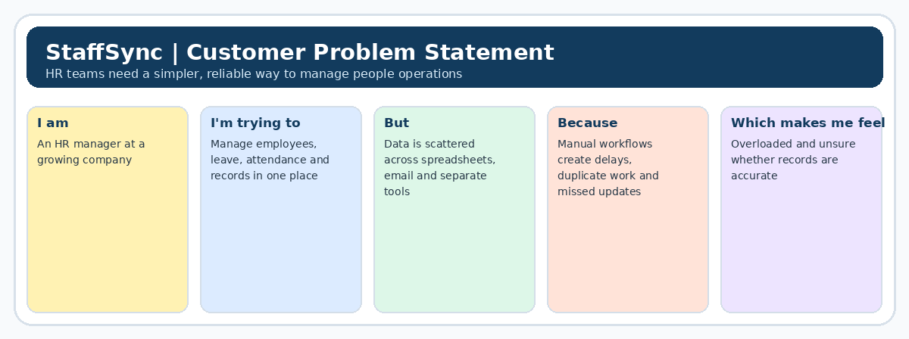
Reference: https://miro.com/templates/customer-problem-statement/

Problem Statement (PS) | I am (Customer) | I’m trying to | But | Because | Which makes me feel
PS-1 | HR manager in a growing organization. | maintain accurate employee records and coordinate attendance and leave in one place. | information is scattered across spreadsheets, emails and separate tools, making updates and approvals difficult to track. | manual data entry, duplicate records and unclear workflows increase administrative effort and the risk of mistakes. | overloaded and less confident that records and reports are always up to date.
PS-2 | employee in a growing organization. | view my attendance, leave balance, HR policies and request status without repeated follow-ups. | I may need to contact HR for routine information and cannot always see where a request stands. | information and communication are spread across different channels, with limited self-service visibility. | frustrated by avoidable delays and uncertain about the status of my requests.
PS-3 | HR administrator or team lead in a growing organization. | review pending requests, monitor attendance patterns and prepare reliable summaries for decisions. | I have to check multiple records manually and may not notice missing information or repeated issues early. | there is no single, clear view of request status and workforce information, and updates may not be recorded consistently. | concerned about avoidable errors, slow decisions and spending time collecting information instead of supporting employees.

